

SCHOOL OF INFORMATICS & IT

Part 1: Project Proposal

Student Name (Matric Number) : MAY THET NAING BO (2303675I)

Tutorial Group : P07Jenny LING (TP)
Tutor : Mr. Ryan Chia

Submission Date : 19/5/2024

Declaration of Originality

I am the originator of this work and I have appropriately acknowledged all other original sources used as my references for this work.

I understand that Plagiarism is the act of taking and using the whole or any part of another person’s work, including work generated by AI, and presenting it as my own.

I understand that Plagiarism is an academic offence
and if I am found to have committed or abetted the offence of plagiarism in relation to this submitted work, disciplinary action will be enforced.

Declaration on the use of Generative AI tools for assignments

Describe how you have used Generative AI tools such as ChatGPT or Dall.E-2 in your assignment.

Show snapshots of the conversations with the AI tool (i.e., the prompts you used and the response you get from the AI tool).

How do you indicate the reference?
The content generated by AI tools are not retrievable except by the user who generated them, so they are considered non-recoverable sources. Although non-recoverable data or quotations in APA Style papers are usually cited as personal communications, with ChatGPT-generated text there is no person communicating. Quoting text from ChatGPT chat is therefore more like sharing the output of an algorithm, with a reference list entry and the corresponding in-text citation.

According to the official APA Style site, ChatGPT references should be cited as:

E.g. OpenAI. (2023). ChatGPT (Sep 25 version) [Large language model].
https://chat.openai.com/chat

Important Note:

- Do not copy answers produced by the AI tool in totality as it is considered as plagiarism.

- Do not rely on any information produced by the AI tool blindly. You should always verify the answer with other sources. Do not assume that these answers provided by the AI tool are correct.

To achieve quality outputs from the AI tool, you should provide good prompt that is clear and

Temasek Polytechnic School of Informatics & IT
Diploma in Information Technology
Cloud Application Development (CIT2C24)
Project Proposal

Practical Class: | P07
Submitted by:  (list all students) | <May Thet Naing Bo> / <2303675I>
Date: | 19 / May / 2024

Table of Contents
Application Description 3
Microservices Architectural Design 7
Design Screenshot 9
Database Design Diagram 12
API Documentation 18

Application Description
Name of the application - TaskFlow
TaskFlow is an efficient cloud-based web application which is designed to help the users organize tasks, note down the important tasks and completely the tasks in time. Its strong functionality and user-friendly interface are designed to improve productivity and optimize job management procedures.

Target audience
Users who wish to manage personal tasks and projects for work, school, or personal use, along with students who want to achieve academic excellence, are the target audience.
The app is designed for individuals or groups of students who wish to successfully complete their assignments and develop better study habits.

- To use the app, users must first register and log in. Once inside, they may see, create, edit, and delete tasks.
- They may also mark tasks as completed, change the deadlines of a task, edit the information and assign it to another user.
- Users can also use keywords to search for specific tasks.
TaskFlow simplifies task management, promoting effective teamwork and planning among teams or projects.

Functions

Number | Function Name | Description | HTTP Method
1. | Sign Up or Create New Account | First-time users will need to sign up to use the app. | POST
2. | Login | Existing users will be able to log into their accounts by providing username and password. | POST
3. | Reset Password | Allows users to reset the password if they forgot. | POST
4. | Sign Out | Users can sign out the app if they do not want to use the app anymore. | POST
5. | Create Task | Users can create new tasks with titles, descriptions and deadlines. | POST
6. | Update Task | Users can edit the information of a task and update the existing tasks. | PUT
7. | Delete Task | Users can delete the unwanted tasks. | DELETE
8. | Search Task | Users can retrieve a list of their tasks or specific tasks. | GET
9. | Assign Task to group members | If the users are in a group, a group leader can assign the tasks to the specific members. | POST / PUT
10. | Fliter Tasks By Status and Assignee | Allows group leaders to filter the tasks based on their status and assigned team member. | GET
11. | Leave Group | Allows a student to leave the group if they are part of that group | DELETE
12. | Update Group Details | Allows group admins to modify the details of an existing group. | PUT
13. | Invite Members | Allows group admins to invite other students to collaborate on a task. | POST

Target Audience

Number | Target Audiences | Audience Interaction
1. | Invidual Students | Students who are assigend as individual users can manage their tasks individually.
2. | Students as Group Leaders | A group leader can assign, delete and update the tasks for the team members.
3. | Student as Group Members | Group members are to complete the tasks assigned by the group leaders.
4. | System Administrator | The system adminstrator is responsible for overseeing the technical aspects of the application, including security, backups and upgrades.

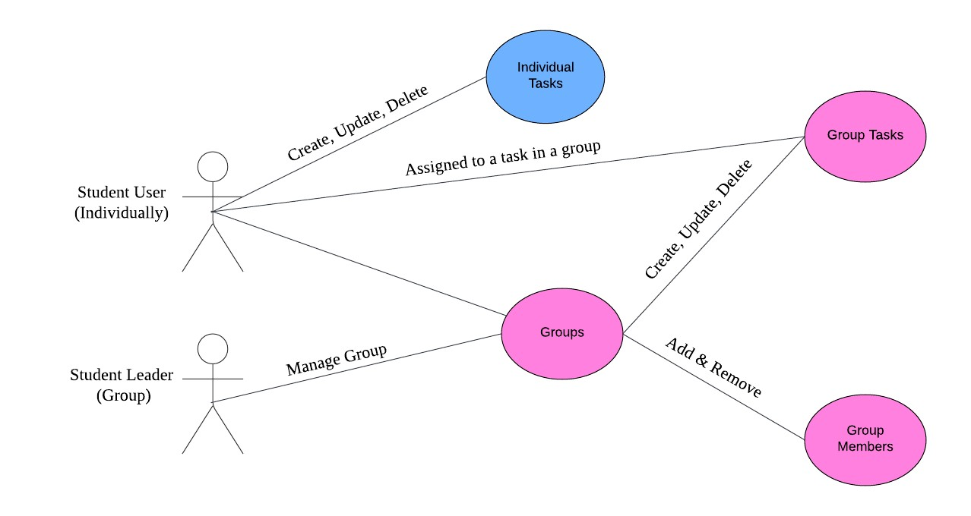
Use Case Diagram

Microservices Architectural Design
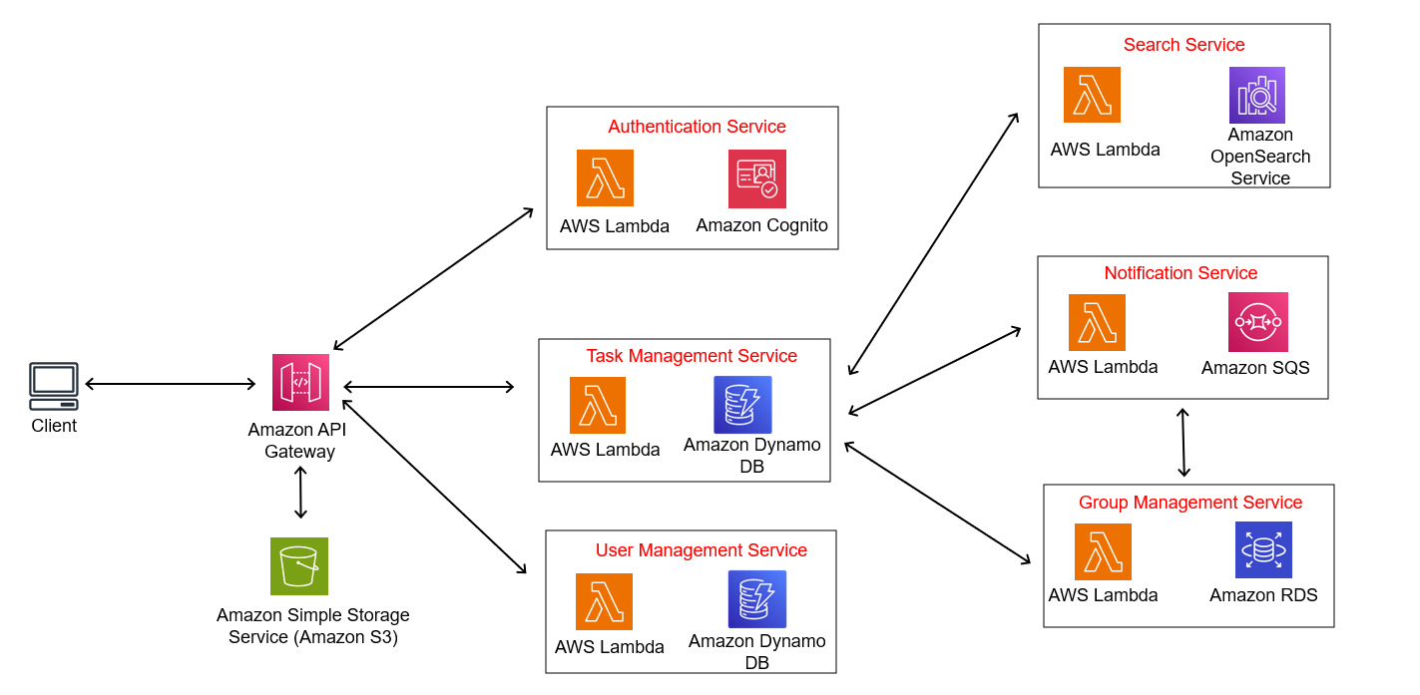

AWS Services Used

Number | AWS Service Used | Purpose
1. | Amazon API Gateway | For creating, publishing, monitoring, maintaining and securing APIs.
2. | AWS Lambda | Allows for scalable and affordable applications by allowing backend codes to be executed in response to events such as HTTP requests.
3. | AWS Cognito | Provides authentication, authorization and makes user management safe and scalable.
4. | Amazon Dynamo DB | A fully managed NoSQL database service for quick and scalable data access
5. | Amazon RDS | A managed relational database service that simplifies database administration tasks.
6. | Amazon SNS/SQS | Allow components of app servers to communicate with one other and deliver messages in a dependable and scalable manner.
7. | Amazon OpenSearch Service | Enables efficient searching
8. | Amazon S3 | Provides scalable storage for files, photos, videos, and data sets.
Reasons:
User Management Service - The Amazon Cognito ensures the authentication services and manages user sign-up, login, sign-out and password rest functionalities.
Task Management Service - Task Management Service ensures effective task management by managing the creation, retrieval, updating, and deletion of tasks. It is implemented with AWS Lambda and Amazon DynamoDB.
Group Management Service - AWS Lambda and Amazon RDS focuses on group creation, updating, deletion, and member invitation functionalities.
Amazon OpenSearch Service is used to manage and enable efficient searching and filtering capabilities for tasks. It is used for its efficient handling of large volumes of data while Amazon DynamoDB stores tasks data for quick access.

Design Screenshot
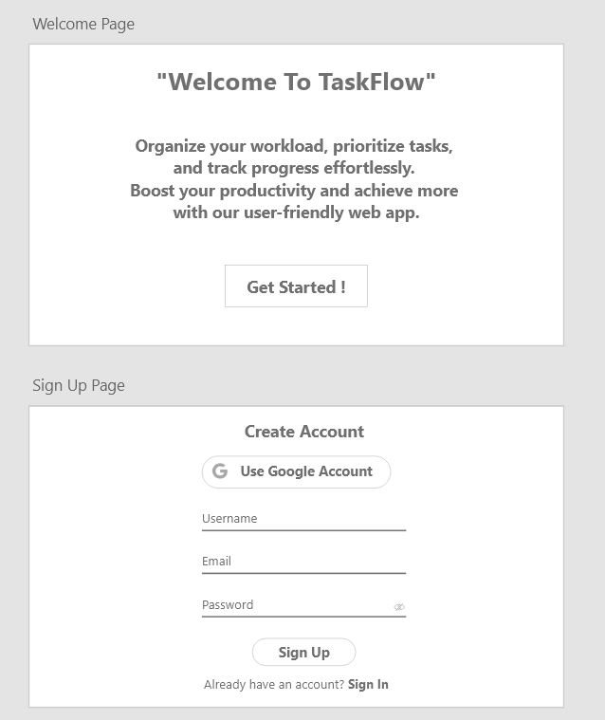
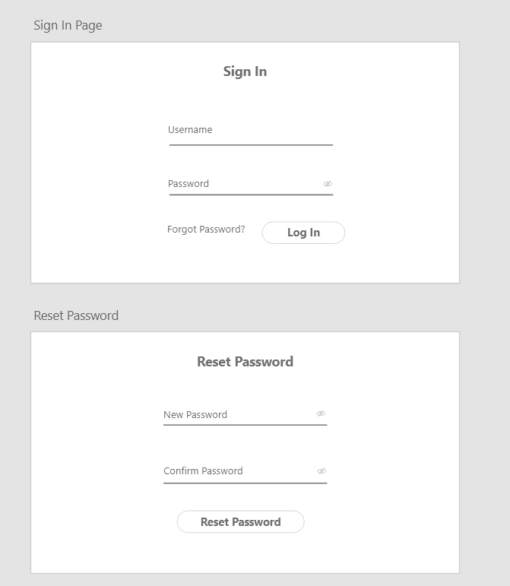
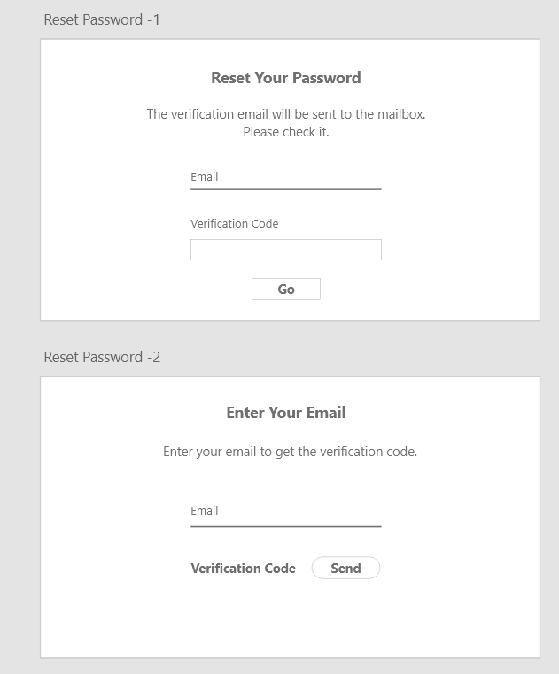
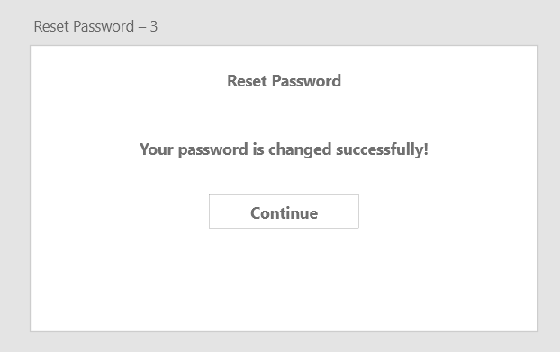
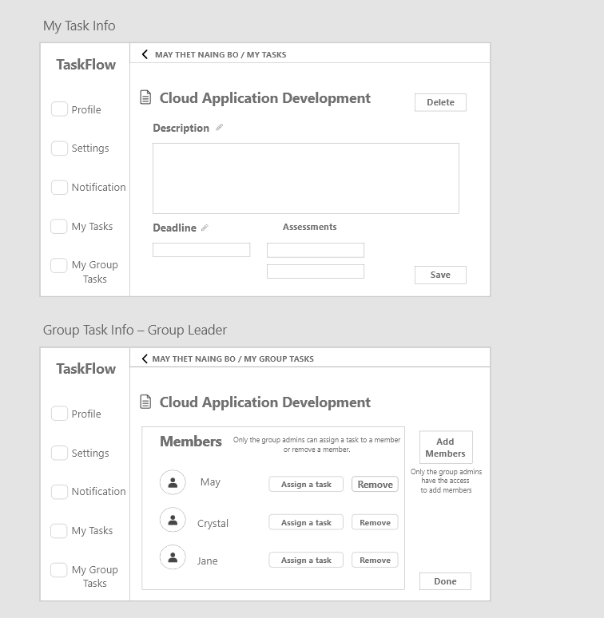
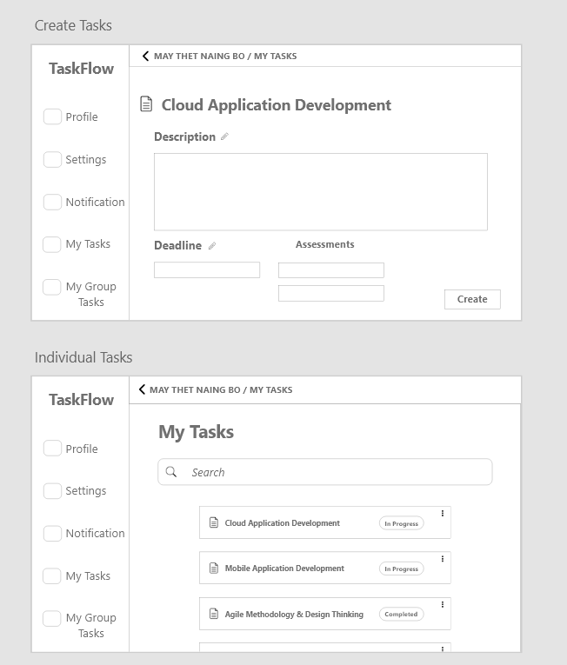
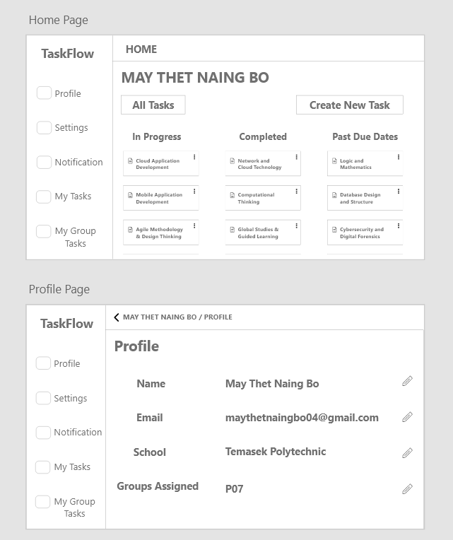
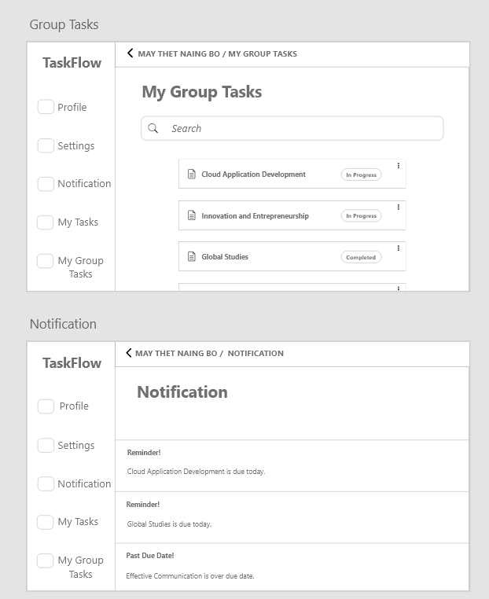
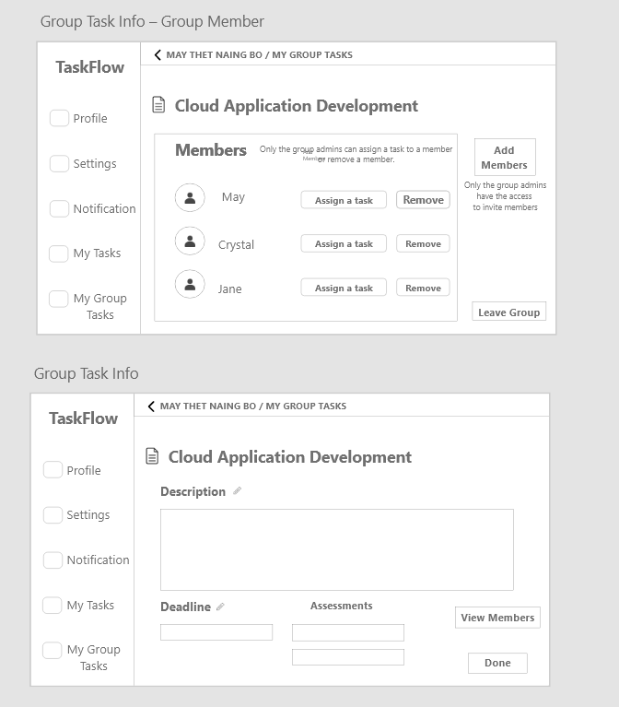

https://xd.adobe.com/view/d26a5b51-92f6-4fa4-ba2d-6320c7e16e59-8739/

Database Design Diagram
ER Diagram (SQL)
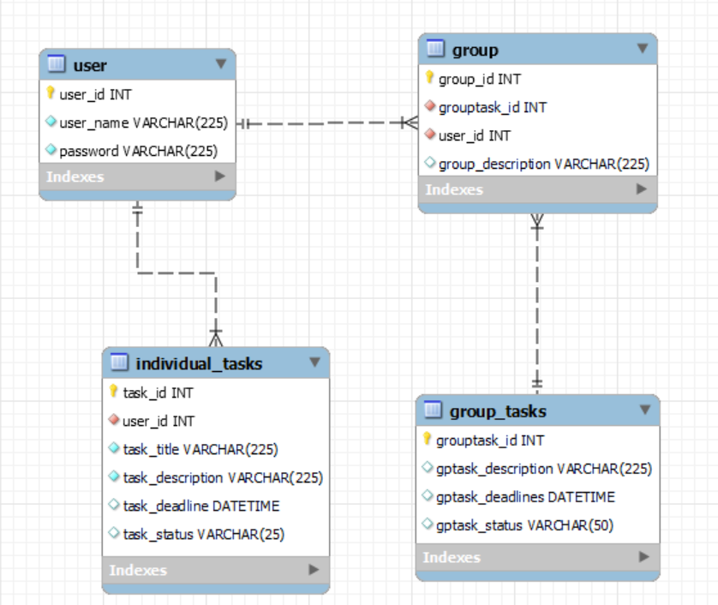

Data Dictionary

User Table: Amazon RDS

Field Name | Data Type | Field Size | Primary/ Foreign key | Description | Example
user_id | Integer | 8 | Primary key | Unique number for the user | 10000001
user_name | Varchar | 225 |  | Name for the user | Crystal
password | Varchar | 225 | - | Password for the user | Mtnb2511

Individual Tasks Table: Amazon RDS

Field Name | Data Type | Field Size | Primary/ Foreign key | Description | Example
task_id | Integer | 8 | Primary key | Unique number for the task | 10000007
user_id | Integer | 8 | Foreign key | Unique number for the user | 10000001
Task Title | Varchar | 225 | - | Title of the product | Cloud Application Development
Task Description | Varchar | 225 | - | Description about the task | Project Proposal Part1
Task Deadline | Date Time | - | - | Deadline of the task | 19/5/2024  11:59 PM
Task Status | Varchar | 25 | - | Status of the task | Completed
Group Tasks Table: Amazon RDS

Field Name | Data Type | Field Size | Primary/ Foreign key | Description | Example
grouptask_id | Integer | 8 | Primary key | Unique number for the group tasks | 10000006
gptask_description | Varchar | 225 | - | Description of the group task | Group Project for Network and Cyberseccurity
gptask_deadline | Date Time | - |  | Deadline for the group task | 19/11/2024  11:59 PM
gptask_status | Varchar | 225 | - | Status of the group task | In Progress

Group Table: Amazon RDS

Field Name | Data Type | Field Size | Primary/ Foreign key | Description | Example
group_id | Integer | 8 | Primary key | Unique id number for the group | 10000006
grouptask_id | Integer | 8 | Foreign Key | Unique id number for the group tasks | 10000006
user_id | Interger | 8- | Foreign Key | Unique id number for the user | 10000006
group_description | Varchar | 225 | - | Description of the group | Consisits of May, Crystal and Jane

Task Table: Dynamo DB

Field Name | Data Type | Partition/ Sort key | Description | Example
task_id | Number | Partition key | Unqiue number for the tasks | 001
Name | String | - | Name of the task | Global Studies
Description | String | - | Description of the task | For the students who do not take oversea trips, the globa studies must be done during flex week.
Deadline | Date&Time | - | Deadline for the task | 26/7/2024  11:59 PM
Status | String | - | Status of the task | Completed

User Table: Dynamo DB

Field Name | Data Type | Partition/ Sort key | Description | Example
user_id | Number | Primary key | Unique number for the user | 2511
user_name | String | - | Name that user chose to have | Crystal
email | String | - | Email address of the user | maythetnaingbo@gmail.com

API Documentation

Service Name | HTTP method | Relative URI | Action
UserService | POST | /api/users | Register as a new user
UserService | POST | /api/users/authenticate | Authenticate a user
TaskService | POST | /api/tasks | Create a task
TaskService | PUT | /api/tasks/{id} | Update a task
TaskService | DELETE | /api/tasks/{id} | Delete a task
TaskService | GET | /api/tasks | Search a task
GroupTaskService | POST/PUT | /api/assign_task/{id} | Assign task to team members
GroupTaskService | GET | /api/filter_task | Filter tasks by status and assignee
GroupTaskService | DELETE | /api/leave/{id} | Leave group
GroupTaskService | POST | /api/invite/{id} | Invite member to task
GroupTaskService | PUT | /api/grouptasks/{id} | Update group details and tasks

